SIMATS ENGINEERING (SAVEETHA SCHOOL OF ENGINEERING)
Department of Artificial Intelligence and Data Science

ASSESSMENT TOOL 2 – SCENARIO BASED

Course Code: | DSA03 | Course Title: | Natural Language Processing
CO Assessed: | CO2 – Manipulation | Assessment: | Assessment Tool 2 – SCENARIO BASED
Weightage: | 30% of CIA
CO5 Statement: | Design inflectional, derivational, finite-state parsing, stemming algorithms and for analyse morphological methods. (BL-3)
Student Name: | R.Mouni | Reg. No.: | 192472283
Section / Batch: | 2024-2028 | Date: | 31-07-2026

Code of Conduct
I R.Mouni 192472283 certify that this submission is my original work and that I have adhered to the guidelines specified for this assessment. I understand that any violation of academic integrity rules will result in disciplinary action.
Signature of the Student: R.Mouni

Instructions
- Read all questions carefully before attempting the answers.
- Answer all five questions. Each question carries equal marks.
- Show all intermediate steps, calculations, probability computations, tagging decisions, and justifications wherever applicable.
- Duration: 30 minutes.

Section / Topic | Focus | Q Nos
English Word Classes, Tagsets for English, Part of Speech Tagging | Morphological decomposition of analyzing, analysis, and analytical; identification of roots, affixes, inflectional and derivational forms, and normalization for indexing. | Q1
English Word Classes, Tagsets for English, Stochastic Part of Speech Tagging | Morphological parsing of disagree, agreement, and agreeable; identification of prefixes, suffixes, base forms, and semantic effects of derivation. | Q2
Counting Words, English Word Classes, Part of Speech Tagging | Morphology-based normalization of govern, government, and governance for topic modeling, clustering, and lexical standardization. | Q3
Rule-Based Part of Speech Tagging, Transformation-Based Tagging | Morphological analysis of activate, activation, and reactivation; identification of derivational layers, wordclass changes, and semantic shifts. | Q4
Rule-Based Part of Speech Tagging,  English Word Classes, Part of Speech Tagging | Inflectional normalization of create, creates, and creating; extraction of root forms and classification of tense/aspect transformations. | Q5

Annexure A – SCENARIO BASED

- A large-scale search engine indexing system processes user queries containing word variants such as “analyzing”, “analysis”, and “analytical”. The system must improve retrieval accuracy by grouping semantically related terms under a unified representation. Design a morphological processing approach to decompose each input word into root and affixes, distinguish between inflectional and derivational forms, and normalize them for indexing. Apply the process to the given inputs and determine the root form along with the morphological structure of each word.

- An AI-based sentiment analysis platform receives product reviews containing words like “disagree”, “agreement”, and “agreeable”. The system must interpret sentiment consistently despite variations in word formation. Develop a morphological parsing strategy to identify prefixes, suffixes, and base forms, while capturing how derivational changes influence meaning. Process the given inputs to extract roots and classify each transformation, ensuring accurate semantic interpretation across all word forms.

- A text analytics pipeline in a news aggregation system handles documents containing terms such as “govern”, “government”, and “governance”. The system must standardize these variations for topic modeling and clustering. Construct a morphology-based normalization mechanism that decomposes each word into its root and affixes, identifies derivational layers, and maps them to a common base form. Apply the approach to the input words and derive the normalized representation along with their morphological breakdown.

4.A document classification system processes input words such as “activate”, “activation”, and “reactivation” to improve semantic grouping and indexing.
Construct a morphological parsing strategy to identify prefixes, suffixes, and root forms while distinguishing derivational layers.
Analyze how prefix addition and suffix transformation affect meaning and word class.
Apply the process to decompose each word and map them to a unified base representation. Derive the morphological structure and normalized root for each input word.

5. A search optimization module processes input words such as “create”, “creates”, and “creating” to ensure consistent retrieval across grammatical variations. Design a morphology-based normalization approach focusing on inflectional transformations such as tense and aspect.
Identify suffix patterns and map all variations to a common base form without altering meaning.
Apply the process to extract root forms and classify each transformation.
Determine the morphological breakdown and normalized output for each word.

Rubrics for Calculation

Criteria | Weighta ge (%) | Level 4 (Exemplary) | Level 3 (Proficient) | Level 2 (Developing) | Level 1 (Beginning)
Understanding of Scenario | 20% | Demonstrates clear and complete  understanding of the scenario and context | Shows good understanding with minor gaps | Partial understanding; misses key aspects | Misinterprets or fails to  understand the scenario
Identification of Key Issues | 20% | Accurately  identifies all  relevant issues and factors involved | Identifies most key issues with minor omissions | Identifies limited issues; some irrelevant points | Unable to identify key issues
Application of Concepts | 25% | Applies appropriate concepts effectively to address the scenario | Applies concepts with minor errors | Limited or partially correct application | Unable to apply relevant concepts
Decision Making | 20% | Makes wellreasoned, logical decisions with strong rationale | Makes reasonable decisions with some  justification | Makes weak  decisions with limited justification | No clear decisions made or  rationale provided
Clarity of  Response | 15% | Response is clear, structured, and logically presented | Generally clear with minor issues | Somewhat unclear or poorly structured | Disorganized  and difficult to understand

Q. No. / Criteria  Level | Understanding of Scenario | Identification of Key Issues | Application of  Concepts | Decision Making | Clarity of  Response | Sub.  Total | Total  %
1
2
3
4
5

Faculty In-charge | Course Coordinator | Program Director
Signature: _______________ | Signature: _______________ | Signature: _______________
Date: ___________________ | Date: ___________________ | Date: ___________________

Q1. Morphological decomposition of analysing, analysis, analytical

Answer)

Morphological analysis is one of the fundamental tasks in Natural Language Processing (NLP). It involves studying the internal structure of words by breaking them into smaller meaningful units called morphemes. Morphemes include the root word, prefixes, and suffixes. Understanding the morphology of words helps computers recognize different forms of the same word and process them correctly.

In search engines and information retrieval systems, users often enter different forms of a word, such as analyzing, analysis, or analytical. Although these words have different grammatical forms and meanings, they are all related to the same concept of analysis. Morphological processing identifies the common root and converts these word forms into a single normalized representation. This process is known as normalization or stemming/lemmatization.

Morphological analysis also distinguishes between inflectional and derivational morphology. Inflectional changes modify the grammatical form of a word without changing its meaning, while derivational changes create a new word or change its part of speech. This distinction helps NLP systems improve search accuracy, document indexing, and text mining by grouping related words under one common base form.

Definition:

Morphological Analysis is the process of breaking a word into its smallest meaningful units called morphemes. It helps NLP systems identify the root word and its prefixes/suffixes so that different word forms can be treated as the same concept.

Types of Morphemes:

- Root/Base: Core meaning of the word.
- Prefix: Added before the root.
- Suffix: Added after the root.
- Inflectional Affix: Changes grammatical form without changing meaning.
- Derivational Affix: Creates a new word or changes the word class.

Morphological Decomposition:

Word | Root | Prefix | Suffix | Type
analyzing | analyze | — | -ing | Inflectional
analysis | analy- | — | -sis | Derivational
analytical | analyze | — | -tic + -al | Derivational

Explanation:

- analyzing
  - Root = analyze • Suffix = -ing
  - Word Class:
    - analyze → Verb
    - analyzing → Verb (Present participle) Meaning remains the same.
Transformation: Inflectional

- analysis
  - Root = analy-
  - Suffix = -sis
Word Class
Verb → Noun
Meaning changes to the process or result of analyzing.
Transformation: Derivational

- analytical
Root = analyze
Suffixes
  - -tic
  - -al
Word Class
Verb → Adjective
Meaning
Related to careful examination.
Transformation: Derivational

Normalized Form for Indexing:

Original Word | Normalized Root
analyzing | analyze
analysis | analyze
analytical | analyze
All three words are indexed as analyze to improve search retrieval.

Python Code:

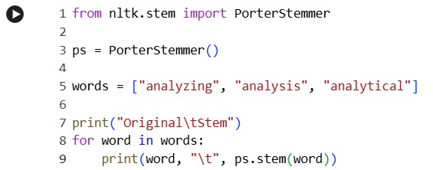

Sample Output:

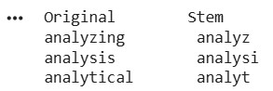

Conclusion:
Morphological analysis is an important NLP technique used to identify roots, prefixes, suffixes, inflectional forms, and derivational forms. By normalizing different word variants into a common base form, NLP systems improve search engines, information retrieval, text classification, topic modelling, sentiment analysis, document clustering, and indexing. These processes ensure that semantically related words are treated as the same concept, resulting in more accurate and efficient language processing.

Q2. Morphological Parsing of disagree, agreement, agreeable

Answer)

Morphological parsing is the process of identifying the internal components of a word, including its prefix, root, and suffix. This technique helps NLP systems understand how words are formed and how their meanings change when prefixes or suffixes are added.

In sentiment analysis applications, understanding word morphology is very important because different word forms can express different sentiments. For example, the word agree has a positive meaning, whereas adding the prefix dis- creates disagree, which expresses the opposite meaning. Similarly, adding suffixes like -ment or -able changes the grammatical category of the word while maintaining its semantic relationship.

Morphological parsing enables NLP systems to recognize these relationships and map all variations to the same root word. This improves the accuracy of sentiment classification, text classification, machine translation, and semantic analysis. By understanding prefixes and suffixes, the system can correctly interpret the intended meaning of words and provide better language understanding.

Definition:

Morphological Parsing identifies the internal structure of words by separating prefixes, suffixes, and roots. It helps NLP systems understand how meanings change due to derivation.

Morphological Breakdown:

Word | Prefix | Root | Suffix | Type
disagree | dis- | agree | — | Derivational
agreement | — | agree | -ment | Derivational
agreeable | — | agree | -able | Derivational

Explanation:

disagree
Prefix = dis- Root = agree
Meaning
Not agree.
Word Class
Verb → Verb
Semantic Effect
Negation

agreement
Root = agree
Suffix = -ment
Word Class
Verb → Noun
Meaning
State of agreeing.

agreeable Root = agree
Suffix = -able
Word Class
Verb → Adjective
Meaning
Able to agree or pleasant.

Normalized Representation:

Word | Base Form
disagree | agree
agreement | agree
agreeable | agree

Python Code:

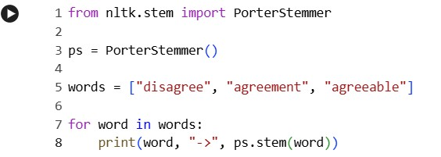

Sample Output:

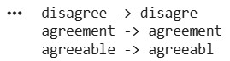

Conclusion:
Morphological analysis is an important NLP technique used to identify roots, prefixes, suffixes, inflectional forms, and derivational forms. By normalizing different word variants into a common base form, NLP systems improve search engines, information retrieval, text classification, topic modelling, sentiment analysis, document clustering, and indexing. These processes ensure that semantically related words are treated as the same concept, resulting in more accurate and efficient language processing.

Q3. Morphology-Based Normalization of govern, government, governance

Answer)

Normalization is the process of converting different forms of related words into a common base form. It is widely used in Natural Language Processing for applications such as search engines, topic modelling, document clustering, and information retrieval. The primary objective is to reduce the number of different word forms representing the same concept.

Words like govern, government, and governance have different grammatical forms but share the same root meaning. Through morphological decomposition, the root word is identified, while suffixes are separated to understand how the word has been modified. This process allows NLP systems to treat all these words as related terms during document analysis.

Normalization improves text mining by reducing redundancy in the vocabulary. It also increases the efficiency of machine learning algorithms because multiple related words are represented by a single normalized form. As a result, topic modelling becomes more accurate, and documents discussing similar concepts can be grouped together effectively.

Definition:

Normalization converts multiple word variants into a common base form so that NLP tasks such as clustering, topic modeling, and indexing treat them as the same concept.

Morphological Analysis:
Word | Root | Suffix | Type
govern | govern | — | Root
government | govern | -ment | Derivational
governance | govern | -ance | Derivational

Explanation:

govern
Word Class
Verb Meaning
To rule.

government Root = govern
Suffix = -ment
Verb → Noun
Meaning
Organization that governs.

governance Root = govern
Suffix = -ance
Verb → Noun
Meaning
Process of governing.

Normalized Form:

Word | Normalized Root
govern | govern
government | govern
governance | govern
This normalization improves document clustering and topic modeling.

Python Code:

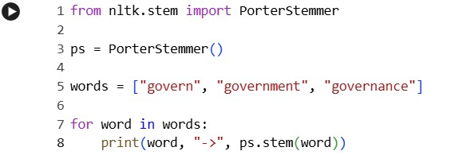

Sample Output:

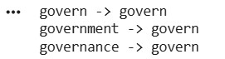

Conclusion:
Morphological analysis is an important NLP technique used to identify roots, prefixes, suffixes, inflectional forms, and derivational forms. By normalizing different word variants into a common base form, NLP systems improve search engines, information retrieval, text classification, topic modelling, sentiment analysis, document clustering, and indexing. These processes ensure that semantically related words are treated as the same concept, resulting in more accurate and efficient language processing.

Q4. Morphological Analysis of activate, activation, reactivation

Answer)

Morphological analysis examines how words are formed through the addition of prefixes and suffixes. In derivational morphology, new words are created by changing the meaning or grammatical category of the original word. Understanding these derivational relationships is essential for NLP applications such as document classification, semantic search, and knowledge extraction.

The words activate, activation, and reactivation illustrate multiple layers of derivation. The suffix -ion converts a verb into a noun, while the prefix re- indicates repetition or doing an action again. Although these words differ in meaning and grammatical category, they are all related to the same base concept.
By identifying the root word and analyzing the derivational layers, NLP systems can group semantically related words together. This improves document indexing, search accuracy, and semantic similarity measurement. Morphological parsing also helps in reducing ambiguity by identifying how prefixes and suffixes contribute to the overall meaning of a word.

Definition:

Derivational Morphology studies how prefixes and suffixes create new words and change their meanings or grammatical categories.

Morphological Breakdown:

Word | Prefix | Root | Suffix | Type
activate | — | active | -ate | Derivational
activation | — | activate | -ion | Derivational
reactivation | re- | activate | -ion | Derivational

Explanation:

activate
Word Class
Adjective → Verb
Meaning
To make active.

activation Root = activate
Suffix = -ion
Verb → Noun
Meaning
Process of becoming active.

reactivation Prefix = re- Root = activate
Suffix = -ion
Meaning
Activation again.
Word Class
Noun

Normalized Representation:

Word | Root
activate | activate
activation | activate
reactivation | activate

Python Code:

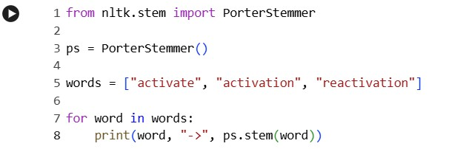

Sample Output:

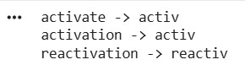

Conclusion:
Morphological analysis is an important NLP technique used to identify roots, prefixes, suffixes, inflectional forms, and derivational forms. By normalizing different word variants into a common base form, NLP systems improve search engines, information retrieval, text classification, topic modelling, sentiment analysis, document clustering, and indexing. These processes ensure that semantically related words are treated as the same concept, resulting in more accurate and efficient language processing.

Q5. Morphological Normalization of create, creates, creating

Answer)

Inflectional morphology studies change in a word that express grammatical information such as tense, number, person, or aspect without changing the core meaning of the word. These changes are important in Natural Language Processing because different grammatical forms should often be treated as the same concept during information retrieval.

The words create, creates, and creating represent different grammatical forms of the same verb. The suffix -s indicates the third-person singular present tense, while the suffix -ing represents the present participle or continuous aspect. Despite these differences, the meaning of the word remains unchanged.
Morphological normalization removes these inflectional endings and converts all forms into the common base word create. This process improves search engine performance, text analysis, and document indexing by ensuring that all grammatical variations are recognized as the same word. It also reduces vocabulary size and enhances the performance of NLP models in various language processing tasks.

Definition:

Inflectional Morphology studies grammatical changes (tense, aspect, number, person) without changing the basic meaning or word class.

Morphological Breakdown:

Word | Root | Suffix | Transformation
create | create | — | Base Form
creates | create | -s | Third Person Singular
creating | create | -ing | Present Participle

Explanation:

create
Root word
Verb

creates
Suffix
-s
Represents
Third-person singular present tense.

creating
Suffix
-ing
Represents
Present participle or continuous tense.

Normalized Representation:

Word | Normalized Root
create | create
creates | create
creating | create
Since these are inflectional changes, their meanings remain the same.

Python Code:

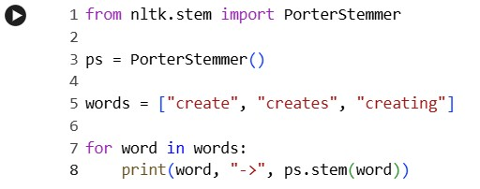

Sample Output:

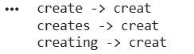

Conclusion:
Morphological analysis is an important NLP technique used to identify roots, prefixes, suffixes, inflectional forms, and derivational forms. By normalizing different word variants into a common base form, NLP systems improve search engines, information retrieval, text classification, topic modelling, sentiment analysis, document clustering, and indexing. These processes ensure that semantically related words are treated as the same concept, resulting in more accurate and efficient language processing.

